**Aim:**

To Calculate the layout function in Gephi.

**Theory:**

**Install layout plugins**

We need to install additional plugins.

• Go to the Tools menu and then Plugins.

• In the Available Plugins tab check:

- OpenOrdLayout

- CircularLayout

- GeoLayout

- Geometric Transformation

- NoverlapLayout

• Click on Install. The plugins are installed and you are asked to reboot Gephi. Click OK.

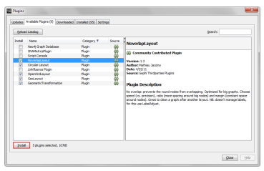

**Open Graph File**

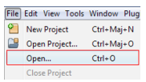

• Download the file



In the menubar, go to File Menu and Open...

When your file is opened, the report sums up data found and any issues.

- Number of nodes

- Number of edges

- Type of graph

• Click on OK to validate and see the graph.

**You should now see a graph**

We imported the “Les Miserables” dataset1. This is a coappearance weighted network of characters in the novel “Les Miserables” from Victor Hugo

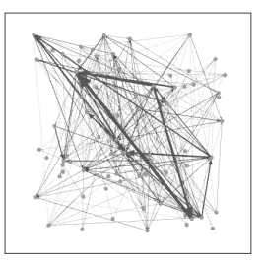

Node position is random at first, so you may see a slighty different representation.

**Run a layout**

Layout algorithms set the graph shape, it is the most essential operation.

• Locate the Layout module, on the left panel.

• Choose “Force Atlas”

You can see the layout properties below, leave default values.

• Click on to launch the algorithm.

• You see now the positions of nodes changing in real time.

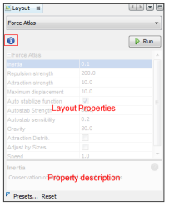

**Layout algorithms**

Graphs are usually laid out with “Force-based” algorithms. They follow a simple principle: linked nodes attract each other and non-linked nodes are pushed apart.

**Control the layout**

The purpose of Layout Properties is to let you control the algorithm in order to make a readable representation.

• Set the “Repulsion strengh” at 10 000 to expand the graph.

• Type “Enter” to validate the changed value.

• And now stop the algorithm.

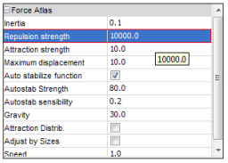



**You should now see a graph with the layout applied**

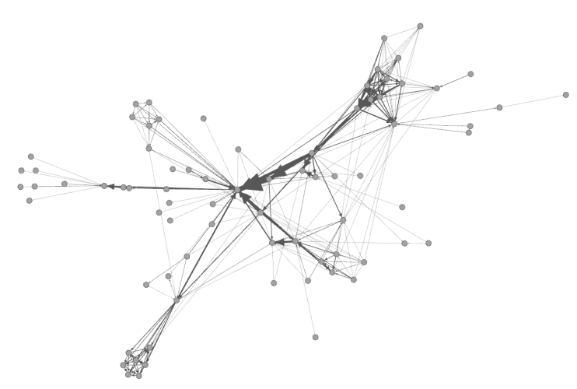

**Play against the algorithm!**

Run the layout again and drag the nodes to stress it.

• Locate Dragging action, in the top left of the Visualization panel.

• Ajust the selection diameter in the panel or by using the shortcut “Ctrl + Mouse Wheel”.

Increase the “Autostab strength” in the Layout Properties to 100 000, then drag the nodes. The graph becomes less deformed.

• And now stop the algorithm.

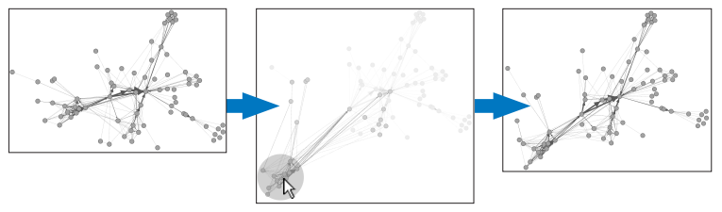

**Various layouts exist**

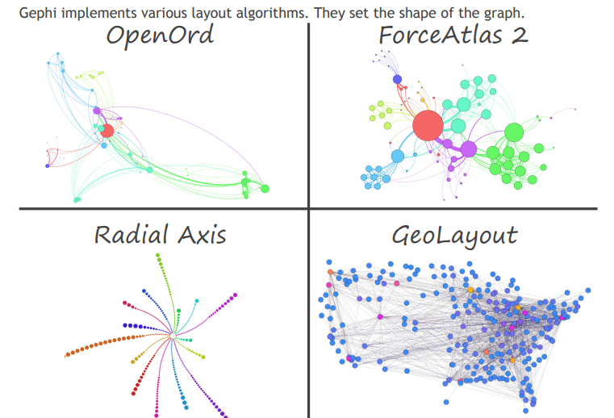

**So how to choose a layout?**

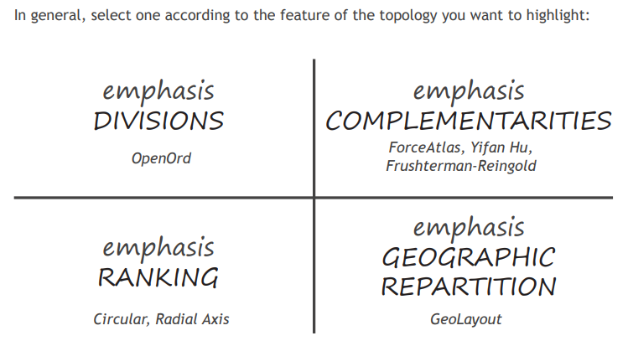

**ForceAtlas layout**

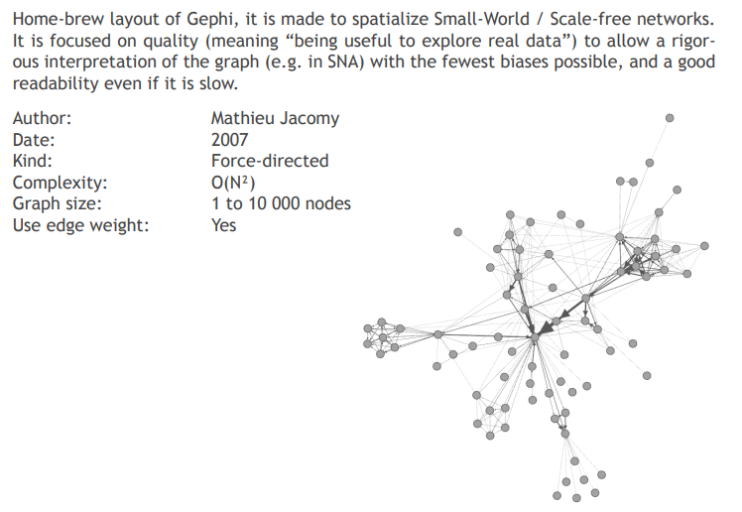

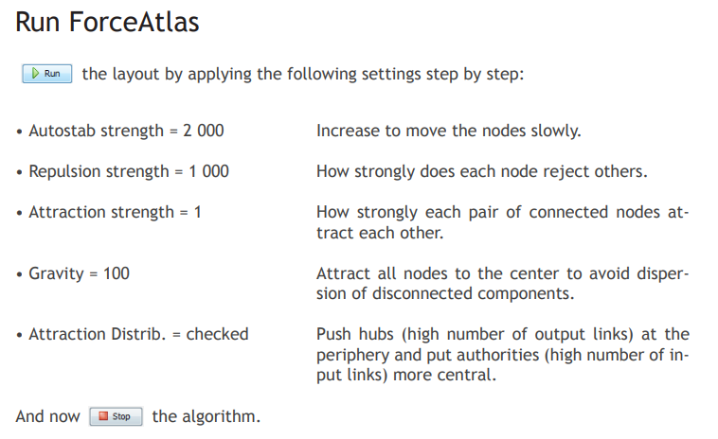

**Fruchterman-Reingold layout**

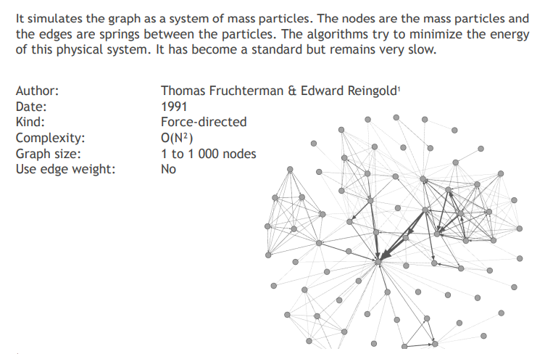

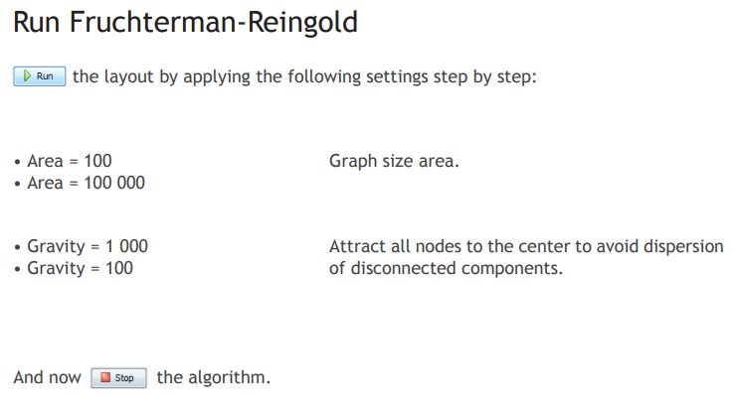

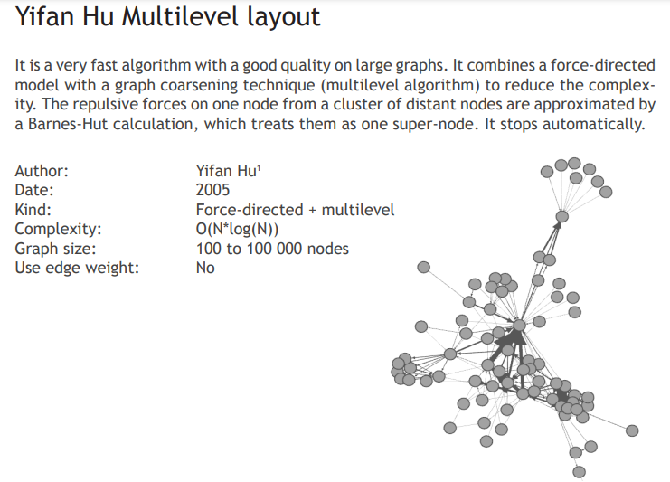

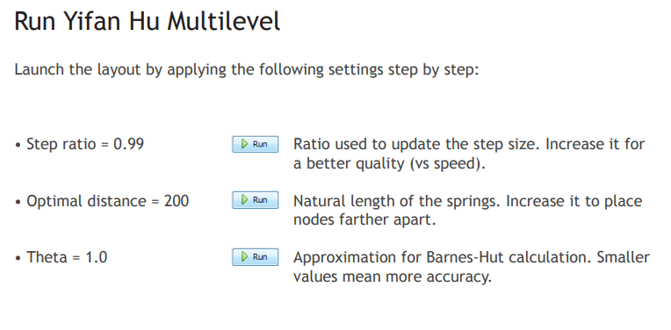

**OpenOrd layout**

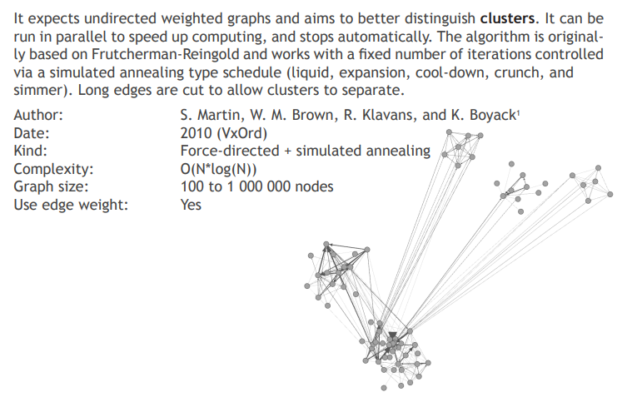

**Run OpenOrd**

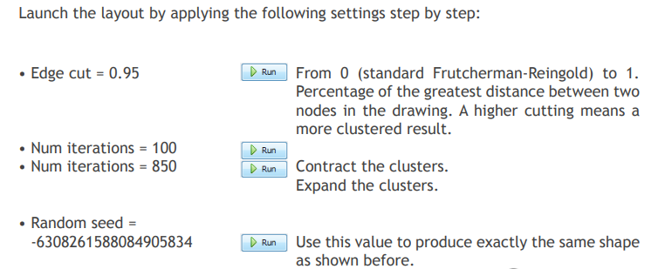

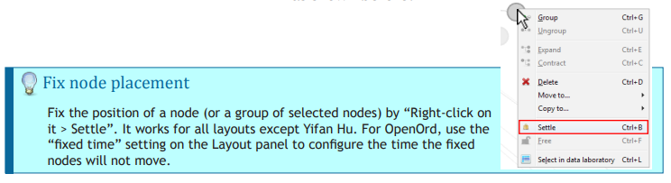

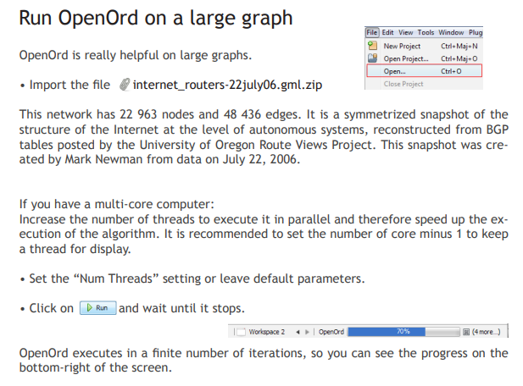

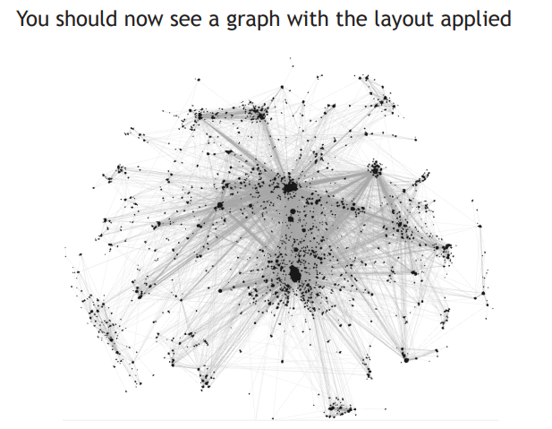

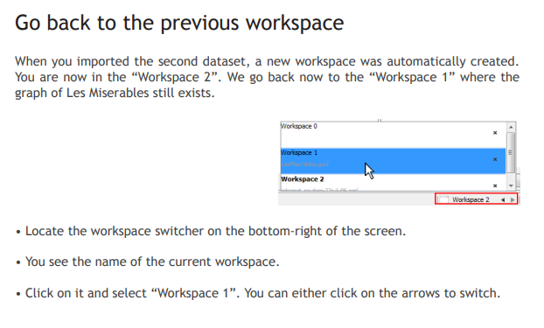

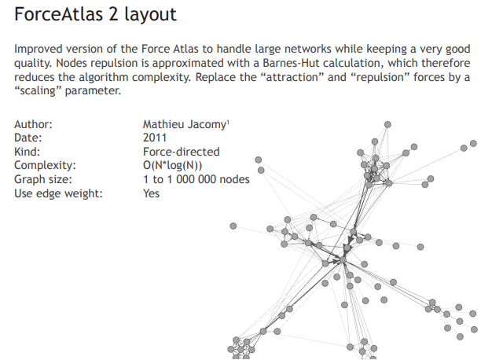

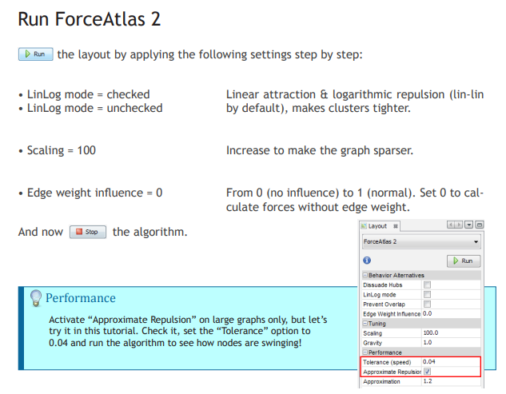

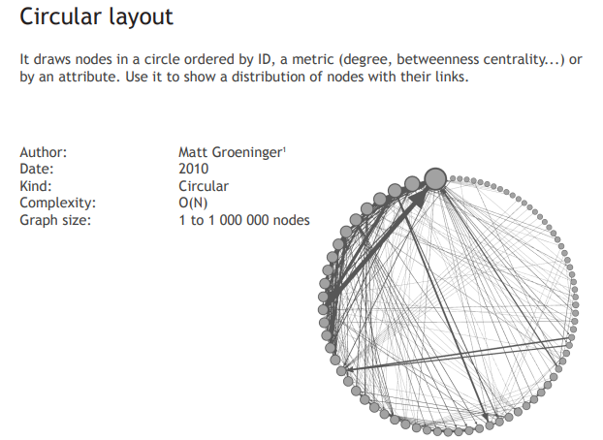

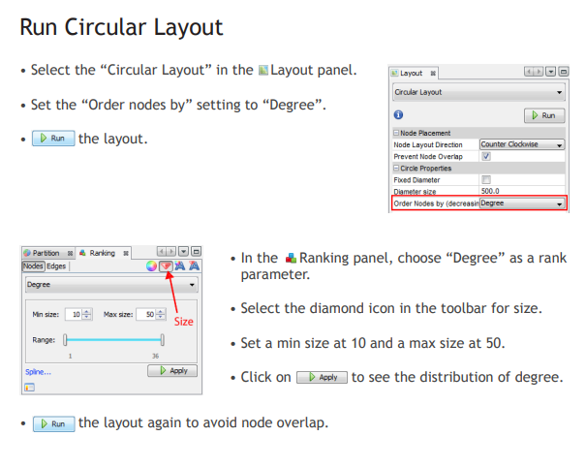

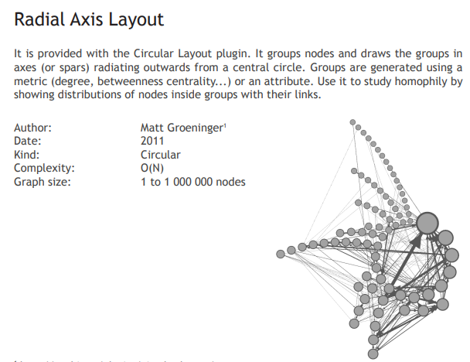

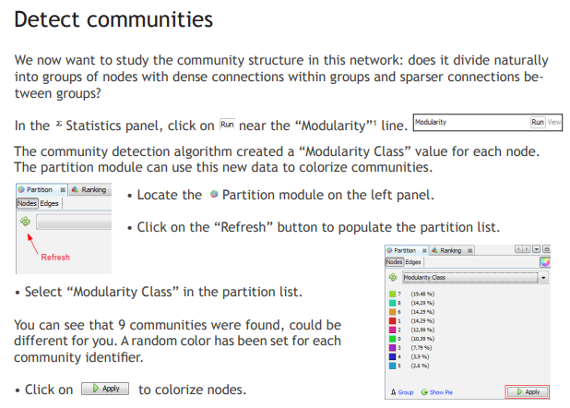

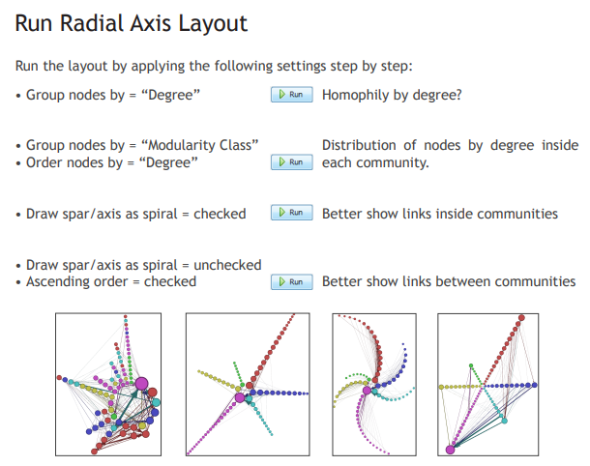

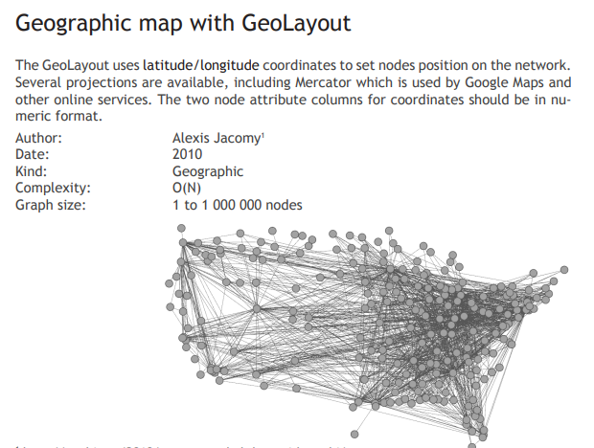

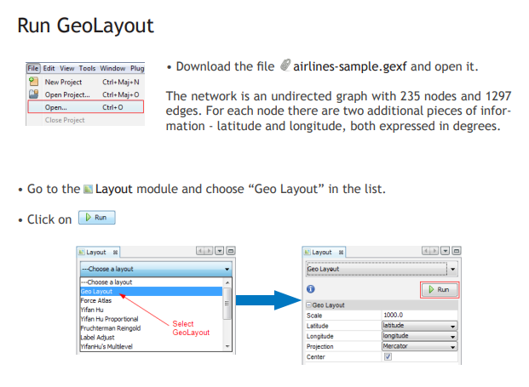

The missing layouts are installed using the below

Tools-🡪Plugin

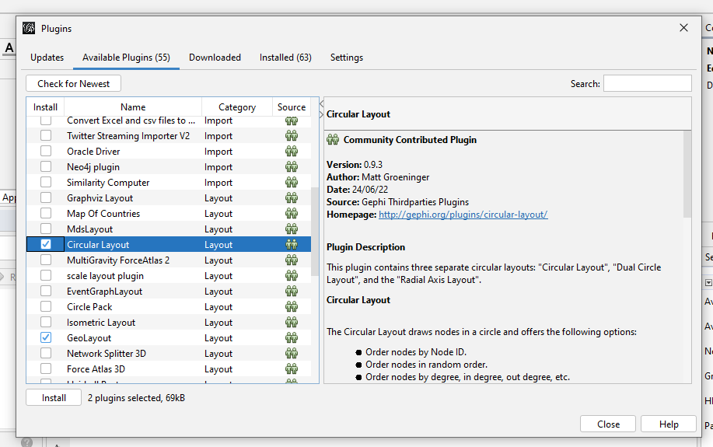

Add the required layouts from the available plugins.

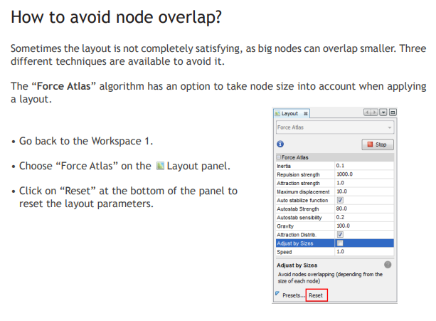

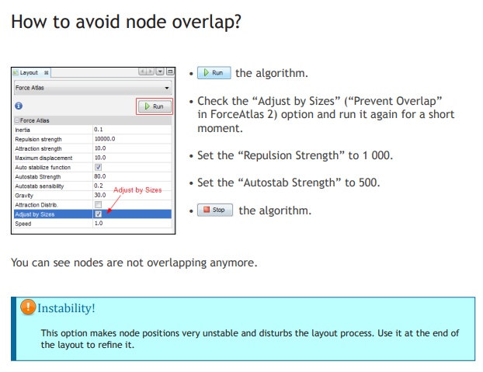

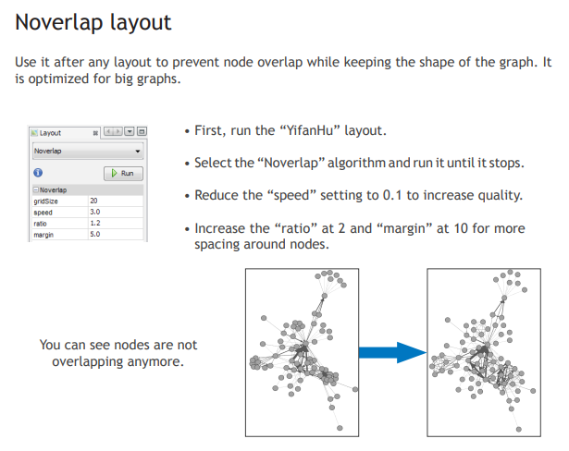

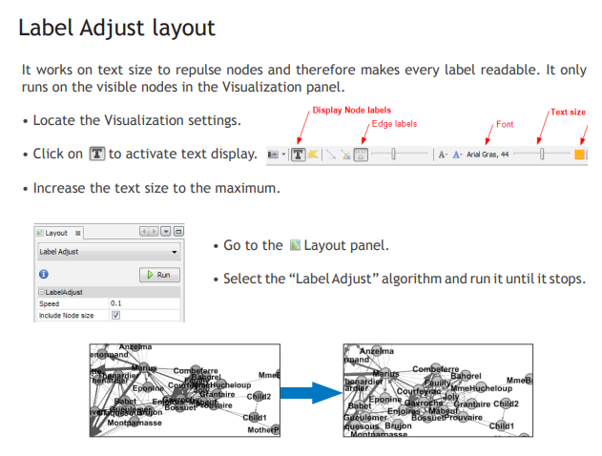

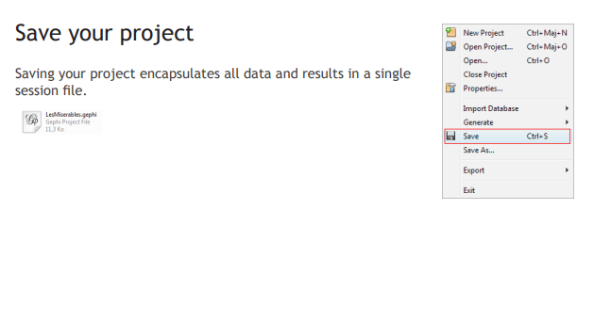

**Result:** Calculating the layout function using Gephi tool has been implemented successfully.